**St Bartholomew’s School Counselling Service**

**What is Counselling?**

Counselling is a confidential service were young people can talk about worries or problems they are experiencing with a qualified counsellor. They can gain new and different perspectives, this can lead to changes in how the young person feels about themselves, their relationships with others, thinking and behaviour. What is spoken about will depend on the individual, but common themes are stress, relationships, change and distressing traumatic events.

**Who is the School Counsellor?**

Our School Counsellor is Kelly Story. She holds a Level 4 Diploma in Therapeutic Counselling and Level 5 Certificate in Counselling Young People. She also has many years of experience in emotional support work, at St Bartholomew’s School, working with young people and their families.

Kelly is a registered member of the British Association for Counselling and Psychotherapy (MBACP)

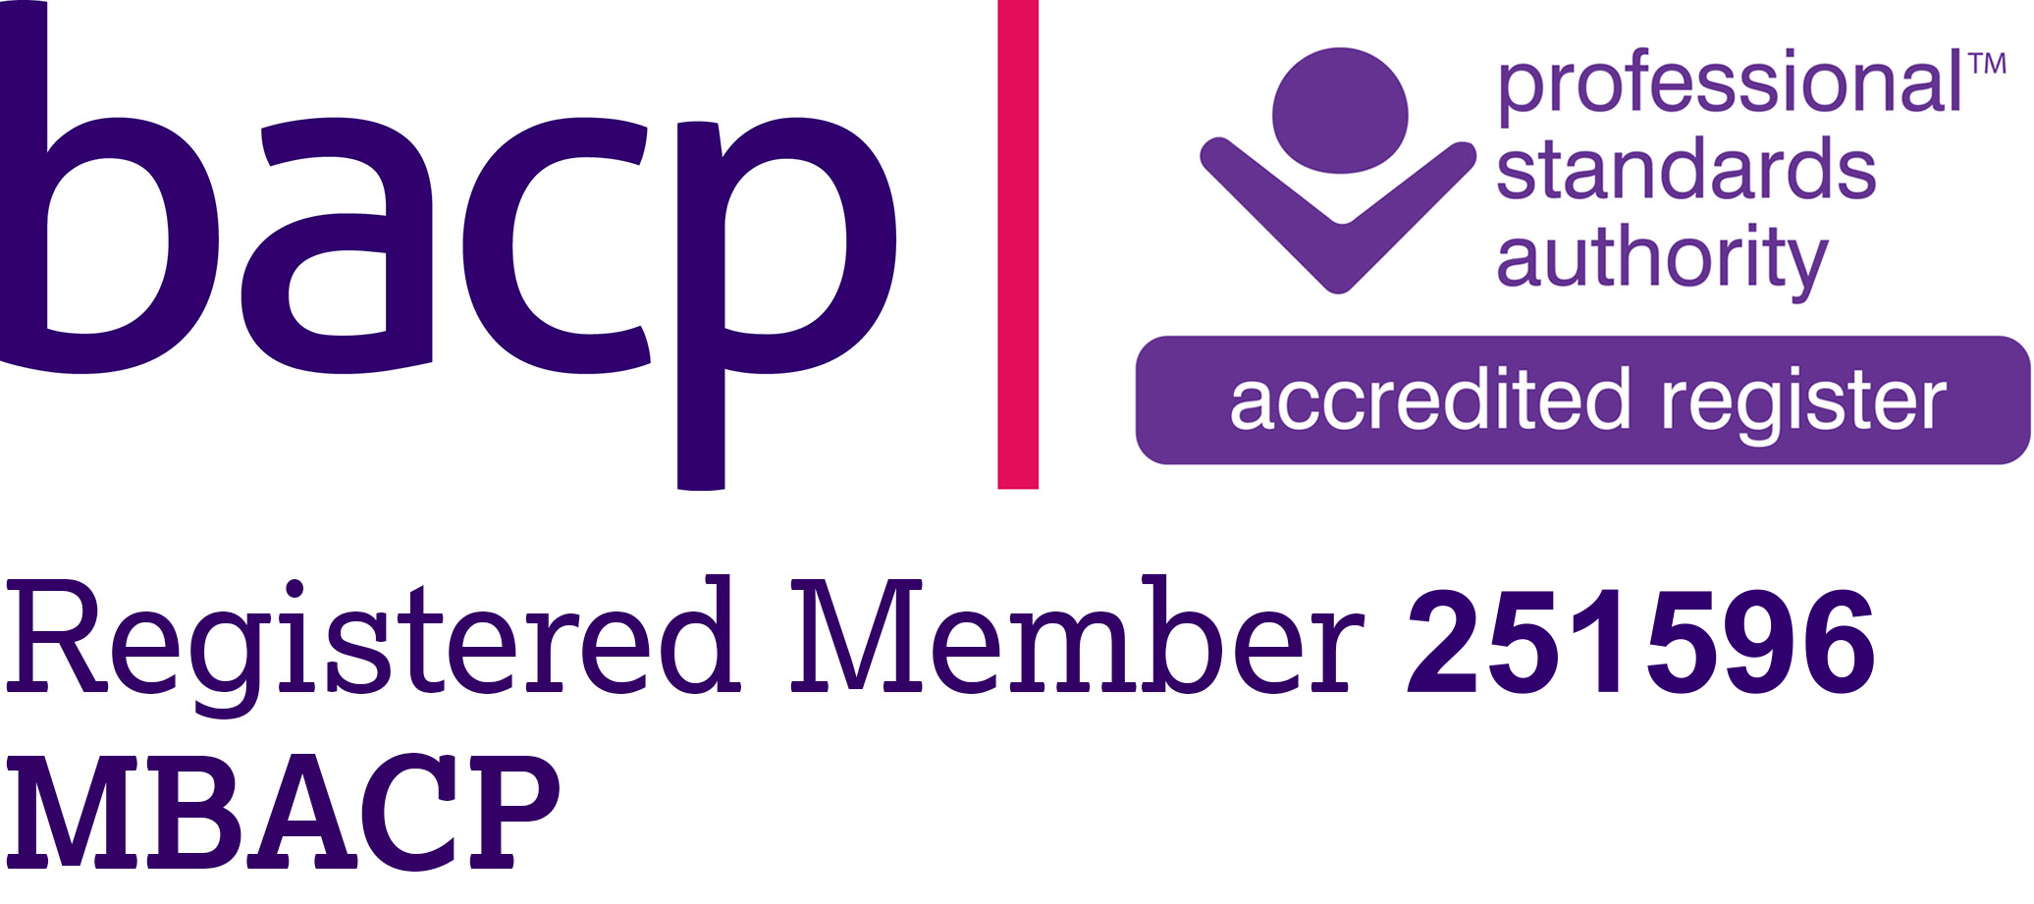

**How can students request to see the School Counsellor?**

Students can request to see the School Counsellor by:

* Dropping a self-referral form into room E132 (Self-referral forms are available from room E132, House Head Offices, and the Sixth Form Office)
* Emailing [kstory@stbart.co.uk](mailto:kstory@stbart.co.uk)
* Asking a member of staff to support them and make a referral on their behalf.
* Asking a parent/ carer to get in touch on their behalf.

Information sheets are available for students and parents/carers with more details about St Bartholomew’s school counselling service. Please request a copy from reception, House Head Offices, or the School Counsellor.

