St Bartholomew’s School
Application for Hire of Facilities: STP & MUGA

CONTACT INFORMATION:
Group/Organisation Name:

Type of Organisation: School/Club/Charity/Business (please delete as appropriate)
Applicant Name: | Invoice Contact (if different):
Address: | Invoice Address:
Telephone Number: | Telephone Number:
Mobile Number: | Mobile Number:
Email: | Email:

BOOKING INFORMATION (please tick): |  | The STP and MUGA are available for Hire during the Autumn and Spring Term as standard. In the Summer there is limited availability as they are used for Tennis. Please indicate if you wish to use in the summer we will endeavour to accommodate but may need to change time/day so are unable to guarantee usage.
Outdoor Synthetic Turf Pitch (whole)
Outdoor Synthetic Turf Pitch - 2 thirds (demarcated with net)
Outdoor Synthetic Turf Pitch - 1 third (demarcated with net)
MUGA (outdoor multi-use)
Grass Sports Pitch

Purpose of Hire:
Booking dates (we are currently able to accept bookings from 04.09.23 until Friday 12 April 2024): | From (Date): |  |  | To (Date):
IF St Barts were able to accommodate, would you wish to continue your hire into the Summer Term 2024? YES / NO
Please indicate day: MONDAY / TUESDAY / WEDNESDAY / THURSDAY / FRIDAY / SATURDAY
Is this booking term time only?  If yes we will assume that you will not be using our facilities at during school holidays.  If no, please indicate here any breaks or holidays within the booking dates when you will not be hiring facilities for correct invoicing. You will be charged during the school holidays. Please note the school closures listed at the end of the form. |  |  | YES / NO  If NO please state any dates you will NOT be attending
Start/End time.  Please note that your slot must include time for setting up and breaking down. Floodlights will be turned off at 9pm due to local regulations. | Start time: |  | End time:
Estimated Numbers Attending:
Any children attending site as part of your booking? (children are defined as any person under 18) | YES / NO
Equipment Requests (EG goals - we do not provide balls/bats etc):

Name of responsible person on site and contact number and their contact number (if different to applicant name):

I hereby agree to hire and use the rooms/facilities/equipment at a rate of ____________________ per hour/agreed fixed rate (delete as applicable) in accordance with the School’s Lettings Terms and Conditions.

I confirm that I will ensure the lettings terms and conditions as set out overleaf will be complied with.

I confirm I have provided evidence of public liability insurance, risk assessment and PAT test where necessary.

Signature: ____________________________________________

Date: ________________________

Please return this form to Facilities, St Bartholomew’s School, Andover Road, Newbury,
Berkshire RG14 6JP Tel: 01635 576342 Email: lettings@stbarts.co.uk

A deposit of £150 must accompany any recurring booking as well as a current PLI Certificate and Risk Assessment. This retainer will be held for the duration of the agreement in case of damage or non-payment. One-off bookings will require advance payment in full.
This form is an application for a booking and it submission is not a confirmation that your booking has been accepted. All bookings are provisional until either the deposit or full payment has been received.
Please note that St Bartholomew’s will prioritise existing community hirers as far as possible. We cannot guarantee that slots will be held indefinitely. Where possible we will try to contact you before passing a reserved slot to another party. In the event of a slot becoming available on the STP we will contact those in the waiting list first. We do not hold a waiting list for any other facility.
Closures: Please note that St Bartholomew’s School is closed at the following times; between the end of the autumn term and beginning of the spring term (Christmas break), over the Easter weekend, and all bank holidays.

SITE SUPERVISOR CONTACT NUMBER: 07721 305506 (for queries during your hire time)
St Bartholomew’s School
SCHOOL LETTING CONDITIONS
1. General Conditions
1.1. Cancellations or alterations must be notified to St Bartholomew’s School as soon as possible and with a minimum of 3 working days clear notice. Failure to adhere to this will result in a full charge for that date. Unless weather conditions are severe and impact the hire, we will not accept cancellations on the day due to inclement weather. If a hirer cancels 4 consecutive weekly sessions or a pattern of regular cancellations are made, their agreement will be terminated.
  - Priority will be given to school events. On occasion we may need to relocate hirers to a different space or cancel the booking due to a school event. In the event of a cancellation, every effort will be made to give as much notice as possible. The school cannot be held responsible for short notice being given due to emergency repairs or health and safety issues including severe weather.
1.3. Premises are let as they normally stand, and no alterations or additions shall be made to the lighting, heating, seating, gangways, fittings, fixtures or other arrangements of the accommodation except with the authority of the Business Manager. Any special requirements such as additional seating are to be requested on the booking form and paid for as appropriate in addition to the basic hiring charge. Stage lighting shall not be used unless the AV Studio is also included in the hire. This hire includes the provision of a trained staff member.
1.4. All passages, stairways and exits to which the public have access shall, at all times when the public are on the premises, be kept free from obstruction.
1.5. Posters or placards will not be permitted on the premises except on boards provided for the purpose.
1.6. No bolts, screws, nail or tacks shall be driven into any part of the premise; neither shall any adhesives be used on walls.
1.7. No article of any inflammable or explosive character, or any article producing an offensive smell, or any oil, electric, gas or other engine shall be brought onto the site.
1.8. Smoking and vaping is not permitted anywhere on site. This includes the car parks and all external grounds. The Hirer, and those using the school premises under the same letting arrangement, must respect this policy. If any damage is caused due to smoking then the Hirer will be financially liable to replace/repair any defect.
1.9. The Hirer shall be responsible for the maintenance of good order and behaviour during the hiring. Persons in charge of activities must be on site before their guests are admitted, and stay until all guests have left. Hirers must act considerately towards neighbours, other hirers and School staff so as not to cause inconvenience, excessive noise, or to create a nuisance – this includes the use of foul and inappropriate language. Incidents of unacceptable behaviour may result in your booking being cancelled.

1.10. St Bartholomew’s School staff will be on site during the lettings to facilitate the hiring and provide assistance in emergency situations. Should staff be subjected to behaviour which causes them to feel threatened by either the Hirer, the persons in charge or their guests, the school will issue a written warning, and reserves the right to cancel the letting, and any future lettings, with immediate effect, if it considers that insufficient action has been taken by the Hirer (see 8.1).
1.11. Should staff observe or become aware of any matter which they consider to be a serious safeguarding concern, then they will immediately halt the activity and report the incident to the appropriate authorities. This may result in cancelling the activity.
1.12. Visitors must park responsibly, observing all restrictions, including not mounting the kerbs. Parking restrictions will be enforced by St Bartholomew’s School staff, and respectful compliance is expected (see 1.9). When the car park is full, please be mindful of our neighbours, and do not park anywhere which would obstruct local residents’ driveways or access within the surrounding roads.
1.13. No intoxicating liquor shall be sold, supplied or consumed without the consent of the Business Manager and with the appropriate licences.
1.14. Attention is directed to Sec. 12 (1) of the Children and Young Persons Act, 1993, which provides that when the number of children attending an event exceeds one hundred, it shall be the duty of the person providing the event to provide an effective corps of properly instructed stewards, to see that the number of children attending does not exceed the proper accommodation of the building and to take all other reasonable precautions for the safety of the children.
1.15. No animals, other than assistance dogs, shall ordinarily be allowed in school buildings or on the school premises.
1.16. Any electrical equipment intended for use at the accommodation must be in good working order and PAT tested. If there is any obvious risk, equipment will not be accepted onto the premises.
1.17. St Bartholomew’s school is NOT a ‘nut free’ environment, and hirers are responsible for having due care towards the allergy conditions of their participants.
1.18. The Hirer shall be responsible for following all safeguarding regulations relating to young and vulnerable persons, including obtaining DBS certificates for all adults working with young and vulnerable persons and ensuring that these certificates are kept current. The school reserves the right to verify these qualifications with the Hirer at any point prior to, and during the hire period. The Hirer must agree to allow St. Bartholomew’s School to review their Child Protection Policy or any other appropriate safeguarding and child protection policies and procedures. Failure to do so will result in the cancellation of the hire and any future hires until the matter is resolved.
1.19. All bookings for a venue are made at the Hirer’s own risk. The Hirer must ensure that all insurances required for the use of the venue are in place. St Bartholomew’s School specifically disclaims all and any liability over the condition of any venue, to the maximum extent permitted by law. Organisations should supply copies of their Public Liability Insurance Certificates when booking. These should be for a minimum of £1,000,000, preferably £2,000,000.
  - The Hirer must ensure that a responsible person will be present on the premises at all times during the period of the letting. If that person is not able to be on site another person must be nominated and the school informed in advance.

  - Hirers should not enter their pitch/room/space before their allotted time. Hirers should vacate their pitch/room promptly at the end of their hire period. Hire times INCLUDE setting up and clearing away.

  - The Hirer agrees that no equipment will be used without approval and that the installation of the Hirer's equipment will be carried out by competent personnel. Any equipment used must be replaced in correct location – this includes sports goals and sports equipment. Electrical equipment must carry a current PAT test label.

  - St Bartholomew's School is responsible for ensuring that the means of access or egress are safe for the use of the Hirers and that plant or equipment used by the Hirers is safe. If the Hirer discovers a hazard in regard to access to school premises or the equipment to be used, he/she should take action to make the Site Supervisor on duty aware of the hazard.

  - The school’s Health & Safety Policy is reviewed by the Governing Body on an annual basis. A statement of general policy is published on the website www.stbarts.co.uk

  - Hirers are responsible for their own First Aid Provision.

  - The site has a one-way system and the speed limit is 5mph. Please ensure all your participants are aware of this and follow them at all times. Speeding and ignoring the one-way system may result in your booking being cancelled and possible termination of the hiring agreement.

- Payment
- 7.1. Invoices will be raised at the end of each month
- 7.2. A deposit of £150 must be made with any recurring booking and prior to the first booking commencing. The deposit will be held for the remainder of the agreement in case of damage or non-payment. One off bookings will require advance payment in full.
- 7.3. Payment terms are 10 days. Queries regarding invoices must be referred to the accounts department within 5 working days of receipt
- 7.4. Payment is requested by direct bank transfer.
- 7.5. Non-payment of invoices will result in the immediate cessation of the hire, and the school may take legal action to pursue any outstanding debt.
2. Fire and Safety Precautions
2.1. Briefing: Persons in charge of activities should ensure that they are aware of the location escape routes, fire alarms and fire-fighting equipment to ensure the safe evacuation of buildings. The Fire Assembly Point is the MUGA
2.2. Fire Instructions – Before use, the person in charge of activities is responsible for ensured that:
2.2.1. Escape routes are unlocked and unobstructed internally and externally and that all doors are easily and immediately operable from the inside.
2.2.2. Seating and gangways are arranged in accordance with the safety rules. Gangways must be at least 1.1m in width and sited to conform with a means of escape; any seat must not be more than 3.66m from a gangway measured along the line of seating.
2.2.3. Fire-fighting equipment is available for immediate use.
2.2.4. Hired spaces are not over-crowded.
2.2.5. Persons in charge of activities are familiar with the layout of the building and fire escape routes – see image below.
Please report any concerns that you have to the Site Supervisor – 07721 305506

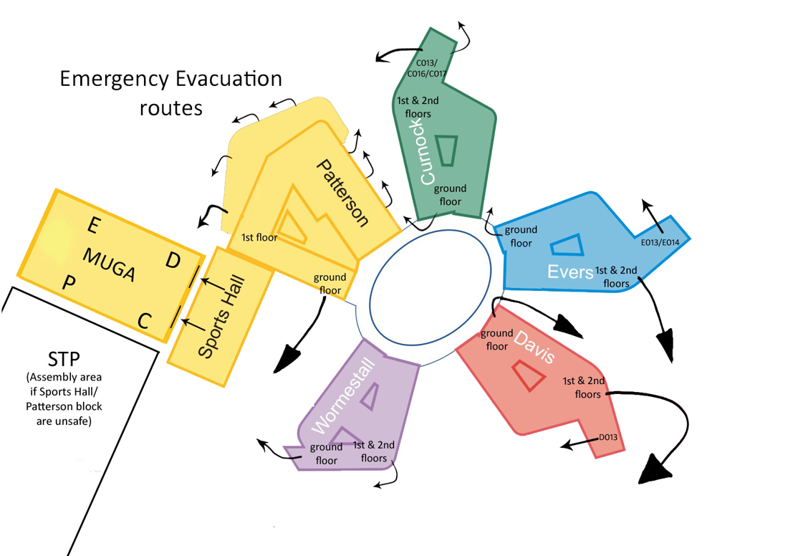
2.3. In the Event of a Fire: the first duty of all concerned is to prevent injury or loss of life.
2.3.1. The Site Supervisor is responsible for calling the Fire Brigade when the alarm sounds
2.3.2. If there is a fire or the fire alarm sounds everyone should leave the building ensuring that all doors which are passed through are closed behind them. The Hirer is responsible for keeping a register of attendees and accounting for all their participants in the event of an evacuation. A check should be made by the hirer on arrival at the fire assembly point to ensure that all persons are present.
2.3.3. No one must be allowed to re-enter the building until the Site Supervisor gives permission.
2.4. After Use of Facilities: persons in charge should check that there are no apparent fire risks. All electrical appliances including workshop machinery, cookers and kilns (when not firing) should be switched off and all doors and windows should be closed when leaving the building.

3. Damage to School Property
3.1. The hirer shall repay to St Bartholomew’s School, on demand, any additional staff costs resulting from the use of the grounds or premises by the hirer and the cost of reinstating grounds or reinstating or replacing any part of the accommodation or any property in or upon the accommodation which shall be damaged, destroyed, stolen or removed during the period of hire or prior or subsequent thereto if in relation to or by the reason of the hiring, in excess of the deposit held by the school.
3.2. No footwear liable to damage floors may be worn in the school buildings.
3.3. No footwear liable to damage the sports hall or pitches may be worn. STP users should always wear appropriate footwear as stated in guidance below:
3.4. The premises must be left in a clean and tidy state, as found at the commencement of the letting. Any additional cleaning undertaken by St Bartholomew's School staff which, in the opinion of the school, occurs as a result of the hiring and outside the scope of the agreed hire charge, will be charged to the Hirer at the appropriate rate.
4. Indemnity
4.1. Against Personal Claims: The hirer shall indemnify the school against all claims, demands, actions, or proceedings, in respect of goods or clothing or of the death or injury of any person, which shall occur during the period of hire or prior or subsequent thereto if in relation to or by reason of the hiring. Provided always that this indemnity shall not apply in the event of any negligence on the part of St Bartholomew’s School, its agents or servants, or any defects in the premises or of an act of God or the King’s enemies.
4.2. Statutory Provisions: Premises shall not be used for any unlawful purpose and in every letting there shall be deemed to be implied on the part of the hirer an undertaking with St Bartholomew’s strictly to observe and perform all statutory provisions and regulations and all conditions and regulations imposed by St Bartholomew’s School applicable to any letting and to indemnify and save harmless. St Bartholomew’s School, its officers and servants from all penalties, damage and costs which they may incur in consequence of any breach or default in complying with any such provisions, regulations or conditions.
4.3. Public Performance of Copyright Work: The hirer shall indemnify St Bartholomew’s against any claims, demands, actions or proceedings arising out of the infringement of copyright, etc, during the period of hire of the premises. The transmissions of oral or visual reproduction of anything, which is taking place in St Bartholomew’s School or of any commentary thereon by any means is prohibited, except with the previous written consent of the school.
5. Rights of Entry
5.1. The Headteacher or representative shall, in pursuance of their official duties, have free ingress and egress to and from the hired premises and instructions must be given by the hirer for their admission.
6. Right of Refusal
6.1. St Bartholomew’s School reserves the right to refuse any application for use of premises and to refuse admission to, or to remove from the premises, any persons. This right applies at any point during the contracted hire period.
6.2. St Bartholomew’s School will pay heed to the risk that the operations of the hirer or the actions of its members may negatively affect the school’s reputation. Should the hirer become aware of any actions or speech by the hirer’s associated members which would reasonably cause St Bartholomew’s School concern, it is the hirer’s duty to inform the school immediately.
8. Failure to Observe Conditions
8.1. If the Hirer fails to observe or perform in any respect, or secure the due observance or performance by others of the provisions of St Bartholomew’s School Terms and Conditions and any notes attached hereto, the school may, without notice, terminate the hirer’s rights under the agreement and effect the immediate vacation of St Bartholomew’s School. Such termination shall not release the hirer from any of her or his obligations under the agreement, or affect any right or remedy which St Bartholomew’s School may have under the agreement or otherwise, and the school shall be entitled to retain for its own use and benefit any monies paid by way of deposit and to sue for any balance outstanding. Termination of any activity may be requested in these circumstances by the Business Manager or representative.
9. Responsibility for Property
9.1. Neither St Bartholomew’s School nor its officers shall be responsible for goods, materials, clothing etc, brought into or left in the building. Cars are parked at owners’ risk.
10. Cancellation of Hiring
10.1. St Bartholomew’s School reserves the right to control any booking in the event of the accommodation being required in connection with any extraordinary or specific civic or educational purposes as the school may from time to time think necessary, or have imposed on them by a government body, or for any other reason at its discretion. In the event of any such cancellation, St Bartholomew’s School shall refund the charges already paid for the hiring of the premises, and the hirer may be offered an alternative date or dates, but in any event, the school shall not be liable by virtue of such cancellation, for the payment of any compensation whatsoever.
10.2. St Bartholomew’s School will ordinarily give a minimum of half a term’s notice (6 weeks) to cease a regular booking (N.B. there are 3 terms per year). Non-payment of invoices will ordinarily result in immediate cancellation.
10.3 A half term’s (6 weeks) notice is required from the hirer to terminate an ongoing booking prior to the end date on the booking form
11. Interpretation
11.1. St Bartholomew’s School decision as to the interpretation of the conditions shall be final and conclusive. Educational and other statutory requirements will take precedence and no application which will interfere with the educational functions of the premises or maintenance of the premises will be approved.
NOTES RELATING TO THE LETTING OF PREMISES: The notes are deemed to be part of the Terms and Conditions of Letting.
12. Before submitting an application the hirer should visit St Bartholomew’s School in order to ascertain that a suitable room with the required facilities is available on the required date.
13. Applications should be submitted to the Lettings Administrator ideally not less than three weeks before the proposed date of use.
14. Statutory Requirements
14.1. Music, Dancing and Singing Licences: Public music, singing and dancing can only take place in premises which have suitable licence/s. Hirers requiring accommodation for this purpose must ascertain from the Business Manager if there is such a licence and, if so, what its conditions are. Applicants must observe the conditions of such licence which, amongst other things, place limits on the hours during which the activity can take place and on the maximum number of persons who can be present in the licensed accommodation.
14.2. Stage Play Licences: Public performances of stage plays, etc, can only take place in premises which have a Licence issued under the Licensing Act 2003. Hirers requiring accommodation for this purpose must ascertain from the Business Manager if there is such a licence and, if so, what its conditions are, particularly in respect of maximum size of audience and seating arrangements.
14.3. Bar Licences: Intoxicating liquor can only be sold in premises that have suitable license/s issued under the Licensing Act 2003. Hirers requiring accommodation for this purpose must ascertain from the Business Manager if there is such a licence and, if so, what its conditions are. Applicants must observe the conditions of such licence which, amongst other things, place limits on the hours during which the activity can take place and on the maximum number of persons who can be present in the licensed accommodation.
15. The Hire Agreement:
Upon receipt of the following documentation:
- Completed Hirer’s Application Form
- Risk Assessment
- Public Liability Certificate
- Confirmation of any electrical items being brought onto site which have been PAT tested
- Confirmation of the £150 deposit being paid in advance of the booking
A confirmation will be sent to the Hirer together with the fire policy and any access information. Hire charges will be invoiced at the end of each month. Any queries regarding the invoice must be referred to the accounts department within five working days of receipt. All settlements are required within ten days of receipt of invoice. The school may take legal action against any hirer who does not settle their invoices as requested. No letting should be regarded as booked until approval has been given in writing and the deposit payment received in full. The school accepts no responsibility where applicants arrange events/activities before the legal process has been completed and the booking confirmation has been issued.
16. Insurance Arrangements
16.1 St Bartholomew's School requires that any organisation operating on of its premises should have a continuing public liability policy to cover claims arising out of all aspects of its activities. Evidence of this must be provided on initial booking, and renewal. The minimum limit of indemnity for this type of policy should be not less than £1,000,000 and preferably £2,000,000.

16.2 Hirers should ensure that their public liability policy includes damage to premises under their control.

